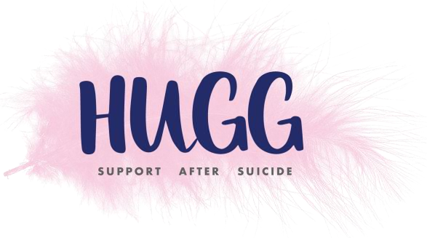
HUGG Walks
Walk, Talk and Connect

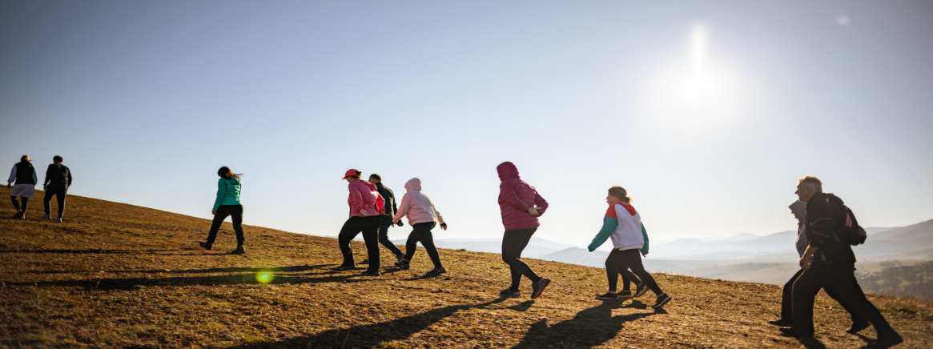

New Year’s Day Walk, Dodder Canal, Charlemont Luas Stop to Milltown, Dublin

While the start of a new year can be a time for hope and renewal, for those of us grieving the loss of a loved one through suicide, this can also be a very challenging time. HUGG, the national suicide bereavement organisation, now offers HUGG Walks: a safe, welcoming space for adults bereaved by suicide to get outdoors, move at a comfortable pace, and connect with others who understand their loss. Each walk is led by an experienced walker and supported by HUGG volunteers.
Next Walk: New Year’s Day Walk, Dodder Canal, Charlemont Luas Stop to Milltown
Date & Time: Thursday, 1st January, 2026, departing 10.30am

You are welcome to join us:
Email: walks@HUGG.ie
Call Helena: 083 433 5701

T: (+353) 1 513 4048 E: info@HUGG.ie W: www.HUGG.ie
Business Address: 13 Adelaide Road, Dublin, D02P950

